**TECHNICAL ARCHITECTURE**

|  |  |
| --- | --- |
| **TEAM ID** | **PNT2022TMID41106** |
| **PROJECT NAME** | **Analy cs For Hospitals' Health-Care Data** |

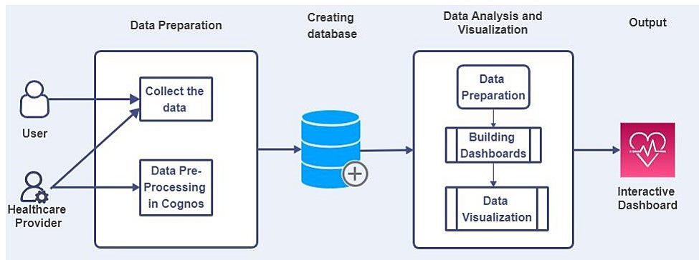

**Table-1 : Components & Technologies:**

|  |  |  |  |
| --- | --- | --- | --- |
| **S.no** | **Component** | **Description** | **Technology** |
| 1 | User Interface | How user interacts with application e.g. Web UI, Mobile App, Chatbot etc. | HTML, CSS, JavaScript /  Angular Js / React Js etc. |
| 2 | Data Processing | The data from the dataset is pre-processed | IBM Cognos Analytics |
| 3 | Database | Database Service on IBM  Cloud | IBM Cloud |

|  |  |  |  |
| --- | --- | --- | --- |
| 4 | File Storage | File storage requirements | IBM Block Storage or Other  Storage Service or Local  Filesystem |
| 5 | Uploading Dataset | Uploading dataset to the IBM  Cognos | IBM Cognos Analytics and python |
| 6 | Data Visualization | The data is visualized into different forms | IBM Cognos Analytics and python |
| 7 | Data Prediction | Prediction of the Length Of  Stay (LOS) | IBM Cognos Analytics and python |

**Table-2: Application Characteristics:**

|  |  |  |  |
| --- | --- | --- | --- |
| **S.No** | **Characteristics** | **Description** | **Technology** |
| 1 | Open-Source  Frameworks | Dashboard frameworks in the form of charts, graphs and more | IBM Cognos |
| 2 | Scalable Architecture | Scalability 3-tier => Database, application, server | Web server – HTML, CSS Application server- Python |
| 3 | Availability | This dashboard is available for health care providers which helps them to managing the hospital resources | IBM Cognos |
| 4 | Performance | This dashboard can contain numerous data and provides interactive visualizing  performance which helps in easy usage | IBM Cognos |